Lagrange Remainder
Given a Taylor series
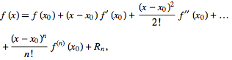 | (1)
the error after terms is given by
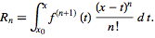 | (2)
Using the mean-value theorem, this can be rewritten as
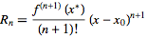 | (3)
for some (Abramowitz and Stegun 1972, p. 880).
Note that the Lagrange remainder is also sometimes taken to refer to the remainder when terms up to the st power are taken in the Taylor series, and that a notation in which , , and is sometimes used (Blumenthal 1926; Whittaker and Watson 1990, pp. 95-96).
